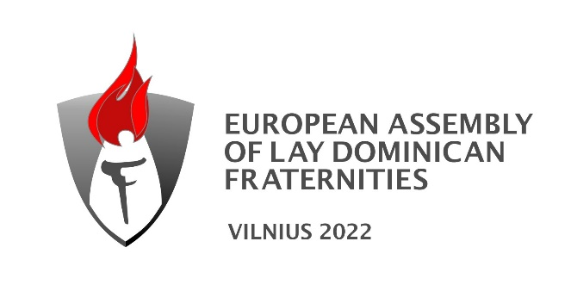

Letter of authorisation
(for delegate with voting rights)

Province / vicariate
Number of fraternities
Number of professed lay dominicans
Date
Name of delegate
Country of delegate

From the above-mentioned Province/Vicariate as been appointed by the Lay Dominican Provincial/Vicarial council to represent his/her Province/Vicariate at the European Assembly to be held in Vilnius, Lithuania, from 12th to 17th August 2022.
Authorisation to vote at the Assembly on behalf of his/her Province/Vicariate.
(Excerpts from the ECLDF statutes concerning the electoral body on the back)

Name of the authorising Provincial/Vicarial Council member :

Position of the authorising Provincial/Vicarial Council member :

Signature :

Extracts from the ECLDF statutes
II. THE ASSEMBLY
A. Composition of the Assembly
1.a. Each Province and Vicariate may send two Lay Dominicans, in temporary or final profession, as delegates to the Assembly.
1.b. Provinces or Vicariates with 500 or more Lay Dominican members in temporary or final profession or 30 or more fraternities may send an additional delegate.
2. A Promoter of each Province and Vicariate shall also attend the Assembly.
3. Those Provinces and Vicariates that consist of more than one country in which there are fraternities may send an additional delegate from each country to participate in the Assembly.
4. Each Province and Vicariate shall send the names of their delegates at least six weeks before the Assembly.
5.a. All delegates shall have a letter of authorization from their Lay Provincial Council testifying that they have been chosen to represent their Province, Vicariate or Country. (See Rule 20c)
5.b. The Province or Vicariate having no Provincial Council may be invited to send one or more representatives of their choice to the Assembly. One such representative shall have a vote.
D. Electoral Body
1. The Council is elected by the Electoral Body, which shall convene during the European Assembly every four years.
2. The Electoral Body is composed of:
a) One Lay Dominican representative mandated by each Province and Vicariate
b) Members of the current European Council.
If a member of the European Council is also a representative, that person shall have one vote only.
3. The Council shall draw up a list of the representatives entitled to vote in the Electoral Body.

